### Semester Two Examination,2018

### Question/Answer booklet

# MATHEMATICS SPECIALIST

**UNITs 3 & 4**

## Section One:

## Calculator-free

|  |
| --- |

Your Name

Your Teacher’s Name

## Time allowed for this section

Reading time before commencing work: five minutes

Working time: fifty minutes

## Materials required/recommended for this section

***To be provided by the supervisor***

This Question/Answer booklet

Formula sheet

***To be provided by the candidate***

Standard items: pens (blue/black preferred), pencils (including coloured), sharpener, correction fluid/tape, eraser, ruler, highlighters

Special items: nil

## Important note to candidates

No other items may be taken into the examination room. It is **your** responsibility to ensure that you do not have any unauthorised material. If you have any unauthorised material with you, hand it to the supervisor **before** reading any further.

**Structure of this paper**

| Section | Number of questions available | Number of questions to be answered | Working time (minutes) | Marks available | Percentage of examination |
| --- | --- | --- | --- | --- | --- |
| Section One:  Calculator-free | 8 | 8 | 50 | 51 | 35 |
| Section Two:  Calculator-assumed | 12 | 12 | 100 | 100 | 65 |
|  |  |  |  | **Total** | 100 |

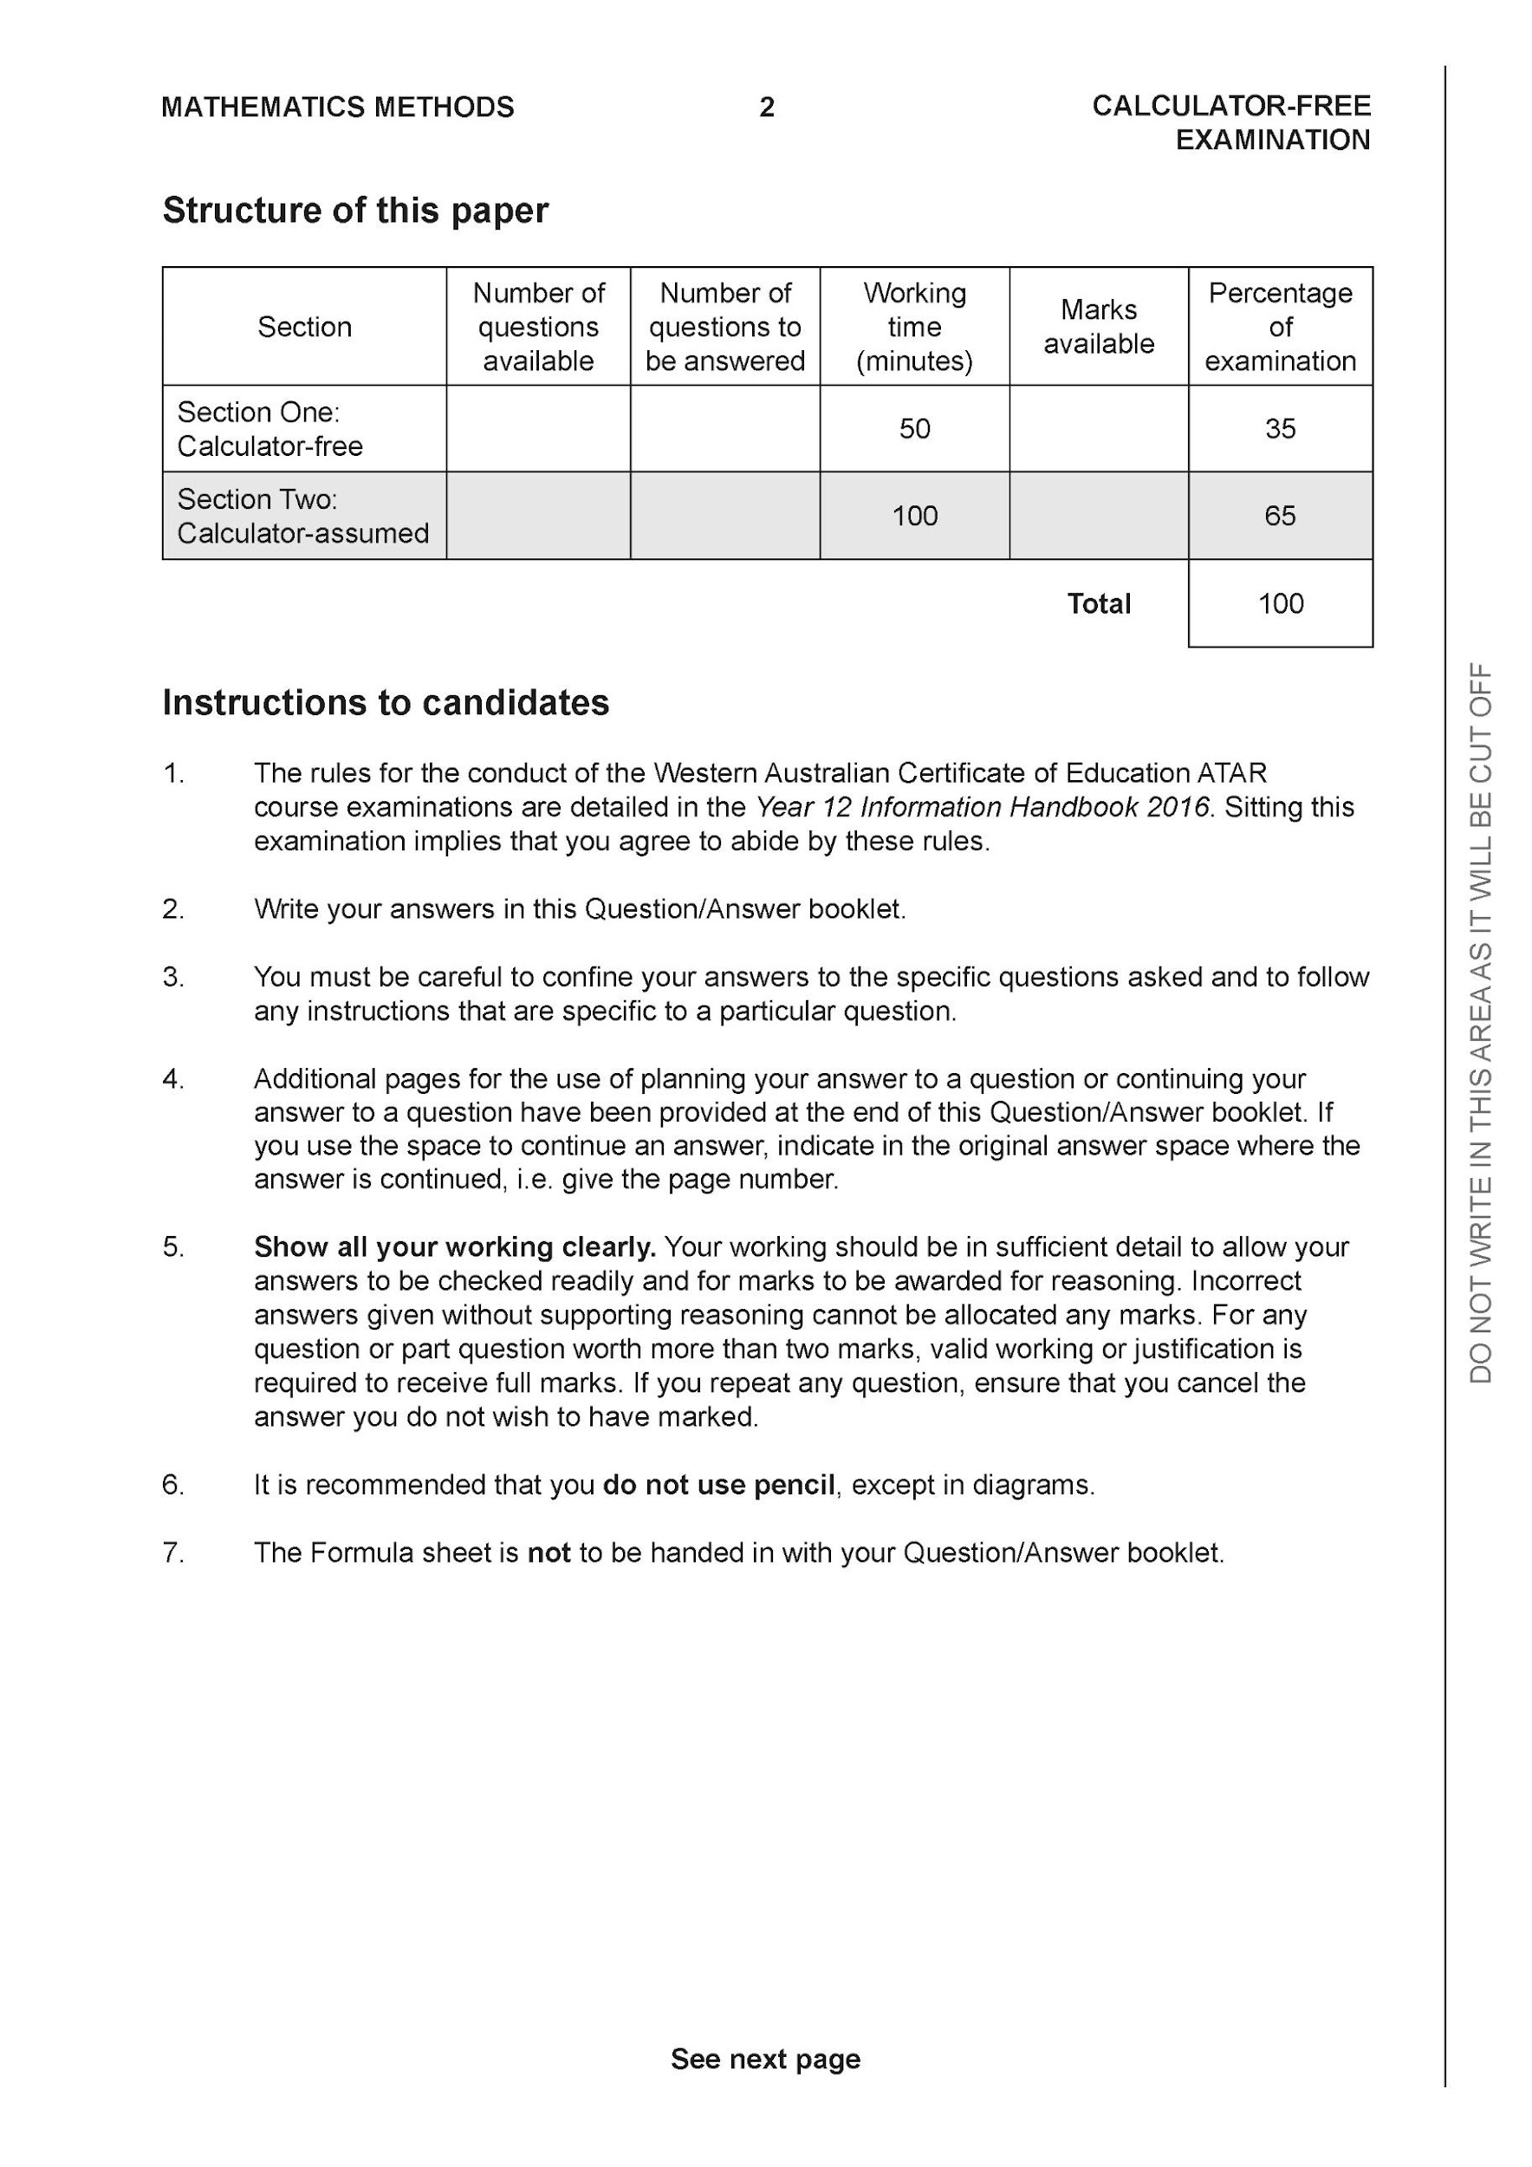

**Section One: Calculator-free (50 Marks)**

This section has **eight (8)** questions. Answer **all** questions. Write your answers in the spaces provided.

Spare pages are included at the end of this booklet. They can be used for planning your responses and/or as additional space if required to continue an answer.

● Planning: If you use the spare pages for planning, indicate this clearly at the top of the page.

● Continuing an answer: If you need to use the space to continue an answer, indicate in the original answer space where the answer is continued, i.e. give the page number. Fill in the number of the question that you are continuing to answer at the top of the page.

Working time: 50 minutes.

**Question 1 (4 marks)**

Consider the function where are a real constants.



Given that are factors of , determine the values of .



| **Solution** |
| --- |
|  |
| **Specific behaviours** |
| ✓ uses f(5i)=0  ✓ obtains two simultaneous eqns for a & b  ✓solves for a  ✓solves for b |

**Question 2 (3 &3 = 6 marks)**

Consider the definite integral



1. By using the substitution show that and state the values of .



| **Solution** |
| --- |
|  |
| **Specific behaviours** |
| ✓ changes limits to u values  ✓ uses  ✓obtains required integral |

1. Hence evaluate exactly.



| **Solution** |
| --- |
|  |
| **Specific behaviours** |
| ✓ uses double angle formula for cos  ✓ anti-differentiates  ✓ subs limits correctly |

**Question 3 (3, 3 & 2 = 8 marks)**

Consider , which is graphed below.

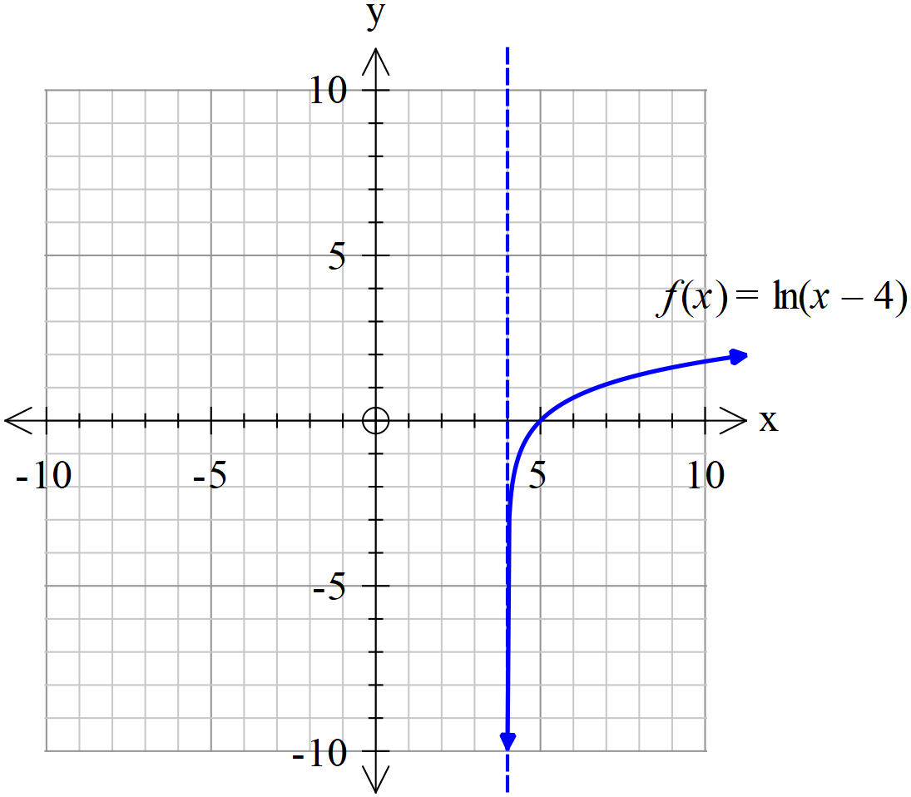

1. Sketch the inverse of on the axes above.



| **Solution** |
| --- |
|  |
| **Specific behaviours** |
| ✓ inverse reflected in y=x  ✓ horizontal asymptote at y=4  ✓y intercept at (0,5) |

1. Determine the rule for stating the domain and range.



| **Solution** |
| --- |
|  |
| **Specific behaviours** |
| ✓ swaps x and y  ✓ uses exponent to rearrange  ✓states domain & range |

1. Determine and the largest possible domain.



| **Solution** |
| --- |
|  |
| **Specific behaviours** |
| ✓ states function rule  ✓ states domain |

**Question 4 (2, 3 & 1= 6 marks)**

Consider the functions where and .



1. Determine the natural domain and range of .



| **Solution** |
| --- |
|  |
| **Specific behaviours** |
| ✓ states domain  ✓ states range |

1. Does exist over the natural domain of? If not then restrict the domain of to give the largest possible domain for to exist.



| **Solution** |
| --- |
| does not exist as is not a subset of |
| **Specific behaviours** |
| ✓ states that composite does not exist with reason  ✓ shows that 25/4 needs to be excluded  ✓states largest possible domain for composite to exist |

1. State the rule for and its corresponding range for your answer to (b).



| **Solution** |
| --- |
|  |
| **Specific behaviours** |
| ✓ states rule  ✓ states range for domain stated in (b) |

**Question 5 (3 & 3 = 6 marks)**

Solve for in the following.



(a) given that contains the point (3 marks)



| **Solution** |
| --- |
|  |
| **Specific behaviours** |
| ✓ states exponential general solution  ✓ solves for constant  ✓states function for y |

(b) given that contains the point (3 marks)



| **Solution** |
| --- |
|  |
| **Specific behaviours** |
| ✓ uses separation of variables  ✓ derives exponent solution  ✓solves for constant |

**Question 6 (6 marks)**

Determine the following integral.



| **Solution** |
| --- |
|  |
| **Specific behaviours** |
| ✓ identifies need to use partial fractions  ✓ gives correct denominators for partial fractions  ✓ uses three constants with partial fractions  ✓solves for all constants with partial fractions  ✓ integrates correct  ✓gives final constant for integral |

**Question 7 (9 marks)**

Consider a rectangular box with points ,,, & all opposite faces are congruent and parallel.

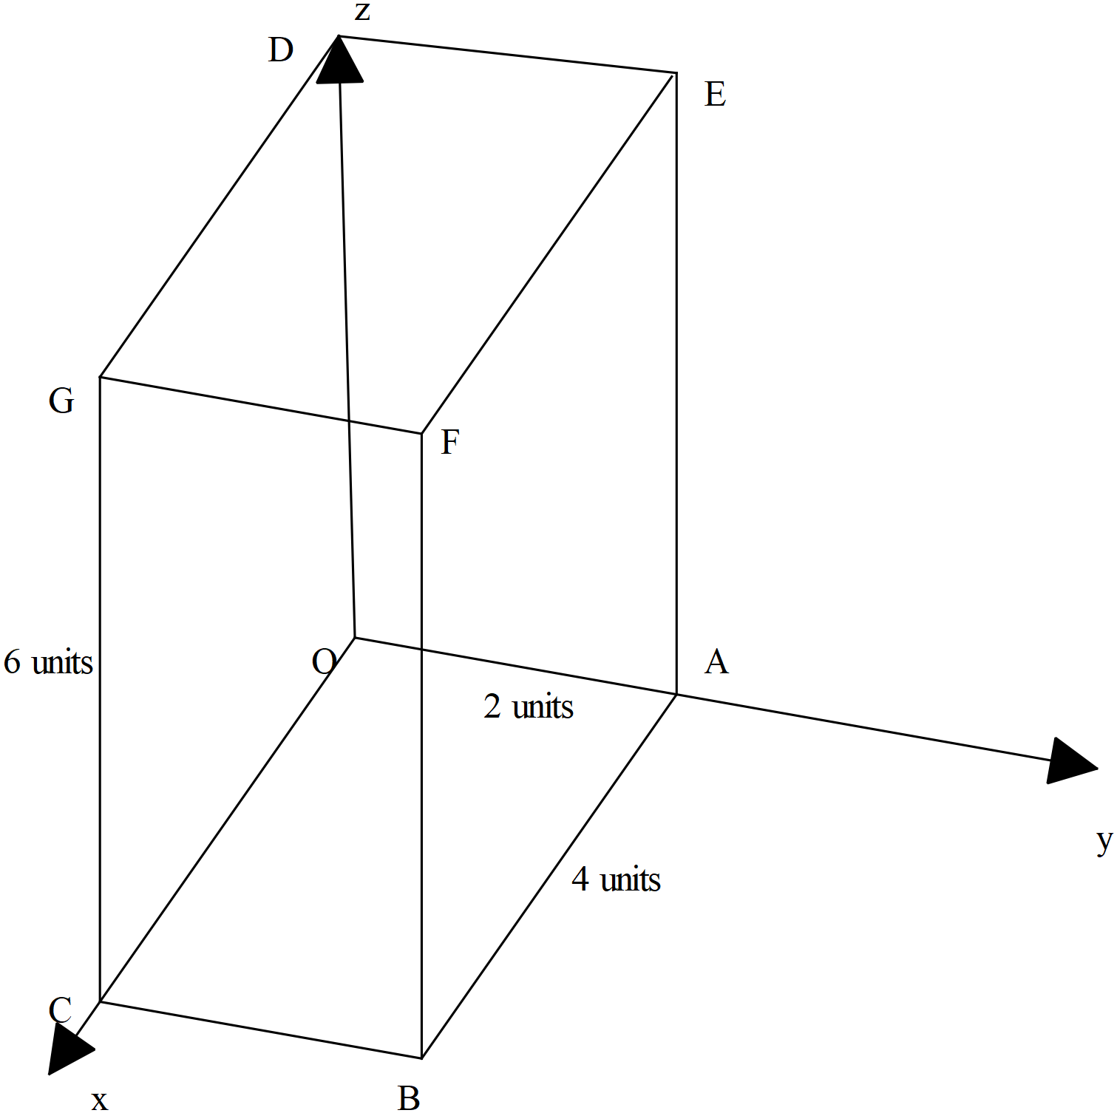

1. Determine the vectors , the diagonals of the rectangular box.



(2 marks)

| **Solution** |
| --- |
|  |
| **Specific behaviours** |
| ✓ states CE diagonal  ✓ states BD diagonal |

1. Prove that the diagonals bisect each other, i.e meet at their midpoints.



(4 marks)

| **Solution** |
| --- |
| Let = midpoint of CE    Let K = midpoint of BD  Diagonals bisect each other |
| **Specific behaviours** |
| ✓ defines midpoints of diagonals as separate points  ✓ determines position vector of midpoint of BD  ✓ determines position vector of midpoint CE  ✓shows that both midpoints are indeed the same point |

1. Determine the cartesian equation of the plane that contains the points .



(3 marks)

| **Solution** |
| --- |
|  |
| **Specific behaviours** |
| ✓ uses cross product of two vectors in plane to determine normal  ✓ uses vector equation of a plane with a pt in plane and normal  ✓determines cartesian equation of plane |

**Question 8 (6 marks)**

Consider the area enclosed between ,the lines and the axis.



If this area is revolved around the axis, a three dimensional object is formed.



Determine the volume of this three dimensional object.

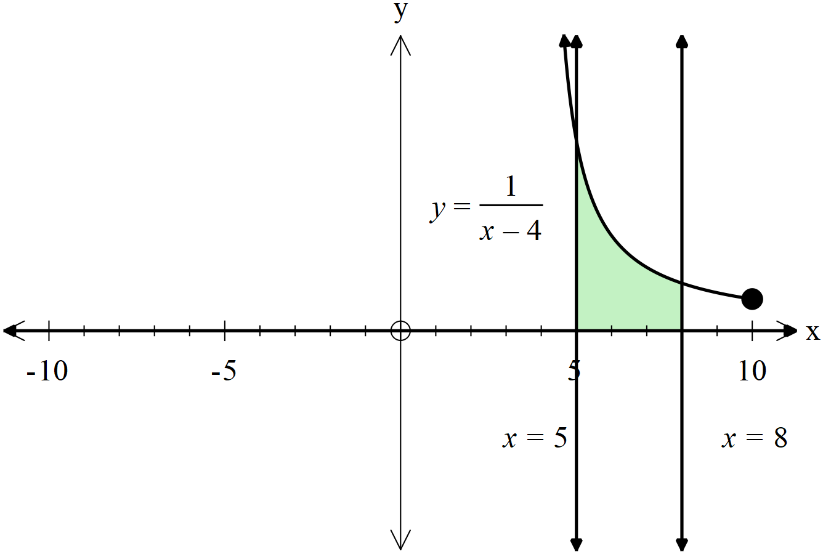

| **Solution** |
| --- |
|  |
| **Specific behaviours** |
| ✓ uses appropriate integral for solid of revolution around y axis  ✓ uses correct y limits for integral above  ✓ adds volume of cylinder with radius 8 and height 0.25 units  ✓subtracts volume of cylinder with radius 5 and height 1 unit  ✓ integrates definite integral  ✓determines exact volume of 3D object |

**Additional working space**

Question number:

**Additional working space**

Question number:

**Additional working space**

Question number:

**Acknowledgements**